Student Ministry
11:00 AM Sample Schedule
Volunteers will serve with students who are in sixth through twelfth grade.
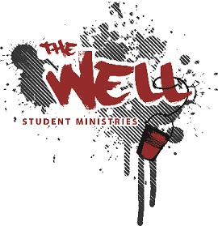
10:30 AM – Arrival and Overview of Materials
10:35 AM – Prayer with Volunteers
10:40 AM – Fellowship with Students
10:55 AM – Direct Everyone Upstairs for Worship
11:20 AM – Return Downstairs After Worship
11:25 AM – Announcements & Teaching Begins
12:00 PM – Small Group Time Begins
12:15 PM – Service Ends

